Cours : Traitement du signal  TP 5 – Sujet 1/2/3/4/5 - Noté  8/1/2026 |  |  | Houssem Gazzah  CIPA4  Nantes
Sauvegarder en PDF et déposer sous Moodle |  | Nom MARQUET  Prenom Félix

Expérience 1
Insérer le code ici
%% Experience 1 : Concatenate three audio files into one

clc;
clear;
close all;

%% Load audio data (Q2, holiday_offer, CLAVES)

[y1, Fs1] = audioread('Q2.wav');
[y2, Fs2] = audioread('holiday_offer.wav');
[y3, Fs3] = audioread('CLAVES.wav');

% Play sound (debug)
%sound(y1, Fs1); % Play the first audio file
%pause(length(y1)/Fs1); % Wait until the first audio finishes
%sound(y2, Fs2); % Play the second audio file
%pause(length(y2)/Fs2); % Wait until the second audio finishes
%sound(y3, Fs3); % Play the third audio file
%pause(length(y3)/Fs3); % Wait until the third audio finishes

%% Force all signals to mono and to the same sampling rate 44100 Hz (CD quality)

Fs_target = 44100; % desired sampling frequency

% Convert to mono
if size(y1,2) > 1, y1 = mean(y1,2); end
if size(y2,2) > 1, y2 = mean(y2,2); end
if size(y3,2) > 1, y3 = mean(y3,2); end

% If needed, resample to 44100 Hz
if Fs1 ~= Fs_target
y1 = resample(y1, Fs_target, Fs1);
end
if Fs2 ~= Fs_target
y2 = resample(y2, Fs_target, Fs2);
end
if Fs3 ~= Fs_target
y3 = resample(y3, Fs_target, Fs3);
end

%% Concatenate the three sounds

y_all = [y1; y2; y3];

%% Save combined sound

audiowrite('Q1marquetfelix.wav', y_all, Fs_target);

%% Play the combined sound

sound(y_all, Fs_target);

Expérience 2
Insérer la figure du spectre de y ici
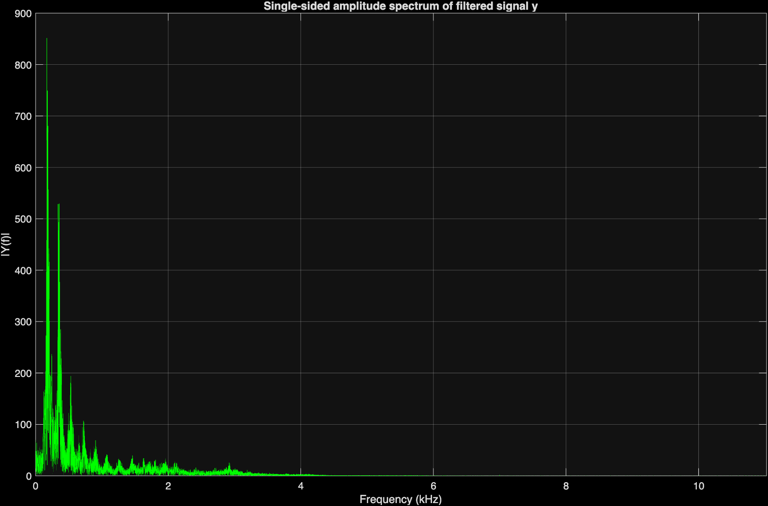
Insérer le code ici
%% Experience 2 : Remove high-frequency jamming from Q2noiz810KA

clc;
clear;
close all;

%% 1) Load audio file with audioread

[x, fs] = audioread('Q2noiz810KA.wav');

% Convert to mono if stereo
if size(x,2) > 1
x = mean(x,2);
end

N = length(x);

%% 2) Listen to the noisy signal

soundsc(x, fs); % Not working on my computer

%% 3) Visualize the spectrum of x and locate the jamming

X = fft(x);
magX = abs(X);

halfN = floor(N/2) + 1;
magX_half = magX(1:halfN);
f = (0:halfN-1) * (fs/N); % frequency axis in Hz

figure('Name','Spectrum of x (noisy signal)');
plot(f/1000, magX_half, 'g'); % in kHz
xlabel('Frequency (kHz)');
ylabel('|X(f)|');
title('Single-sided amplitude spectrum of x');
grid on;
xlim([0 fs/2000]);

%% 4) Find the jamming frequency and filter

fjam = 4000;
ordre = 6;
[b, a] = butter(ordre, fjam/(fs/2), 'low');
y = filter(b, a, x);

%% 5) Listen to the filtered signal

soundsc(y, fs); % Not working on my computer
%audiowrite('test.wav', y, fs); % To avoid using soundsc

%% 6) Plot spectrum of y

Y = fft(y);
magY = abs(Y);
magY_half = magY(1:halfN);

figure('Name','Spectrum of y (filtered signal)');
plot(f/1000, magY_half, 'g'); % in kHz
xlabel('Frequency (kHz)');
ylabel('|Y(f)|');
title('Single-sided amplitude spectrum of filtered signal y');
grid on;
xlim([0 fs/2000]);

Expérience 3
Insérer les figures
1)  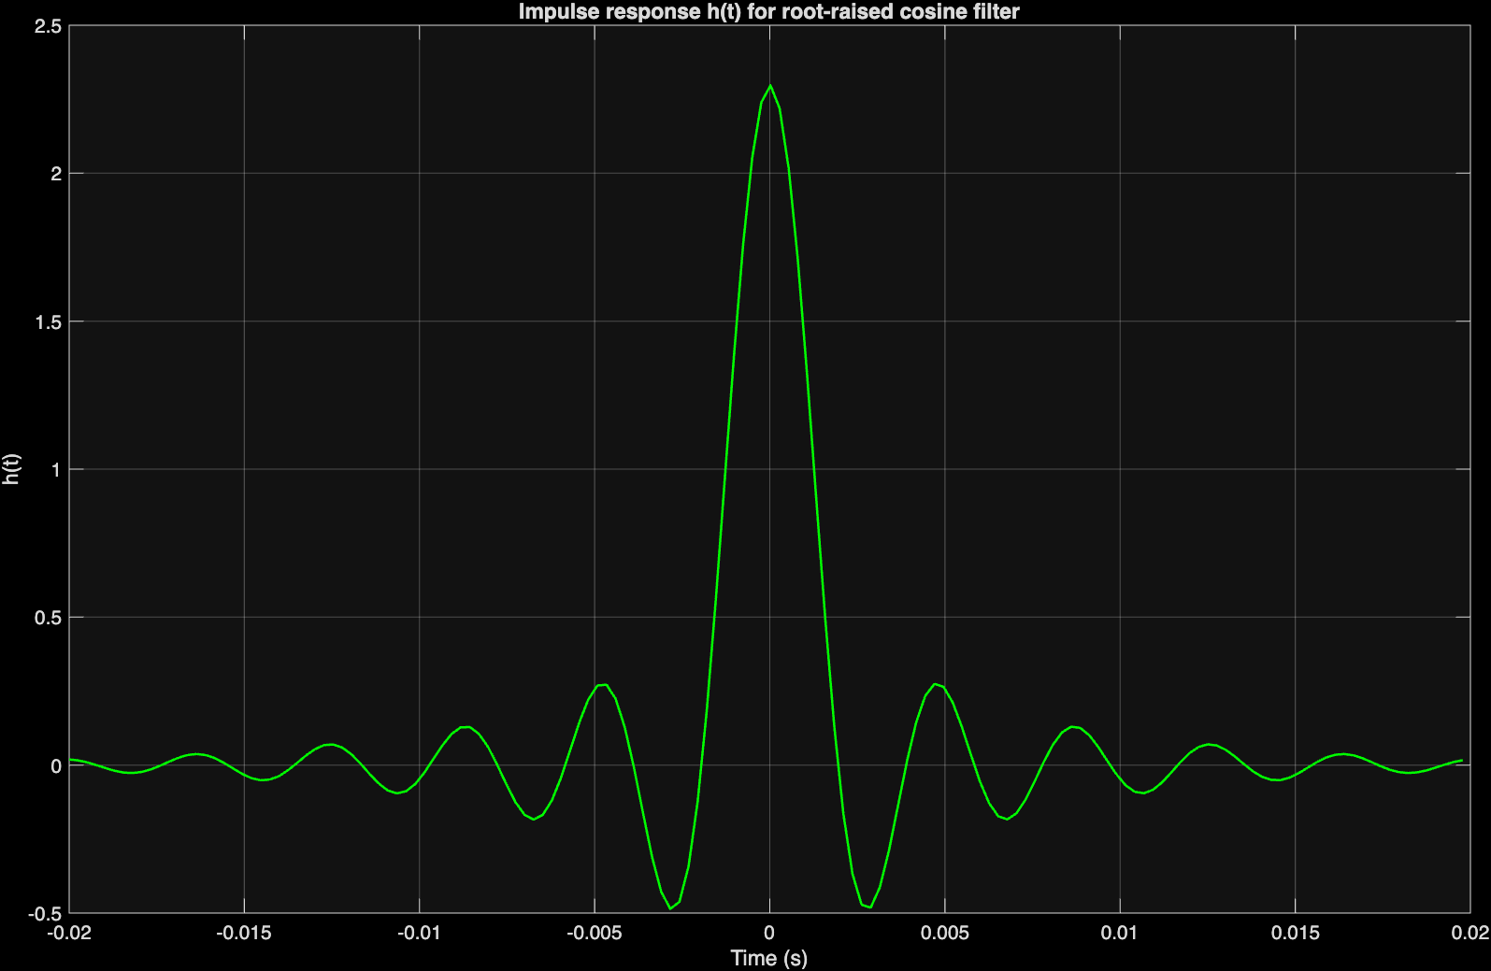 | 2)  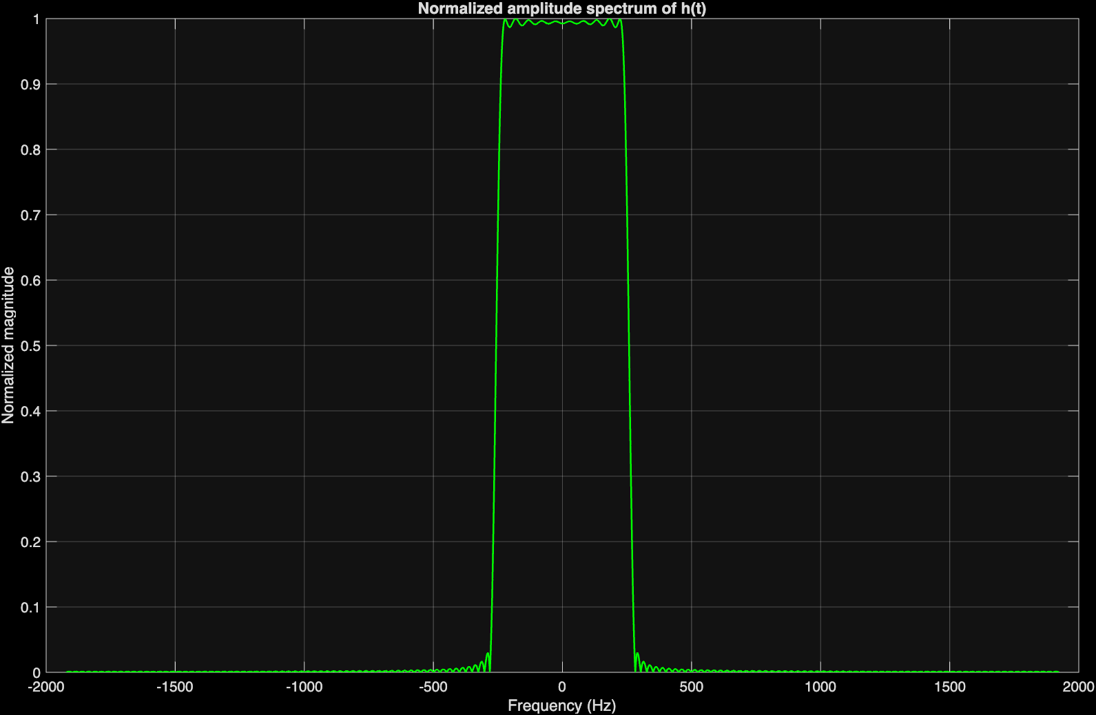
3) Quelle est la valeur maximale à ne pas dépasser ? Justifier
Fréquence max du filtre : fmax = (1 + alpha) / (2T)
Théorème de Nyquist : il faut Fs >= 2*fmax donc Ts <= 1 / (2*fmax) = T / (1 + alpha)
Avec T = 2 ms et alpha = 0.25 : Ts_max = 2 ms / 1.25 = 1.6 ms
Donc la valeur maximale à ne pas dépasser est 1.6 ms pour éviter l’aliasing.

4) Insérer les figures ici
h(t)  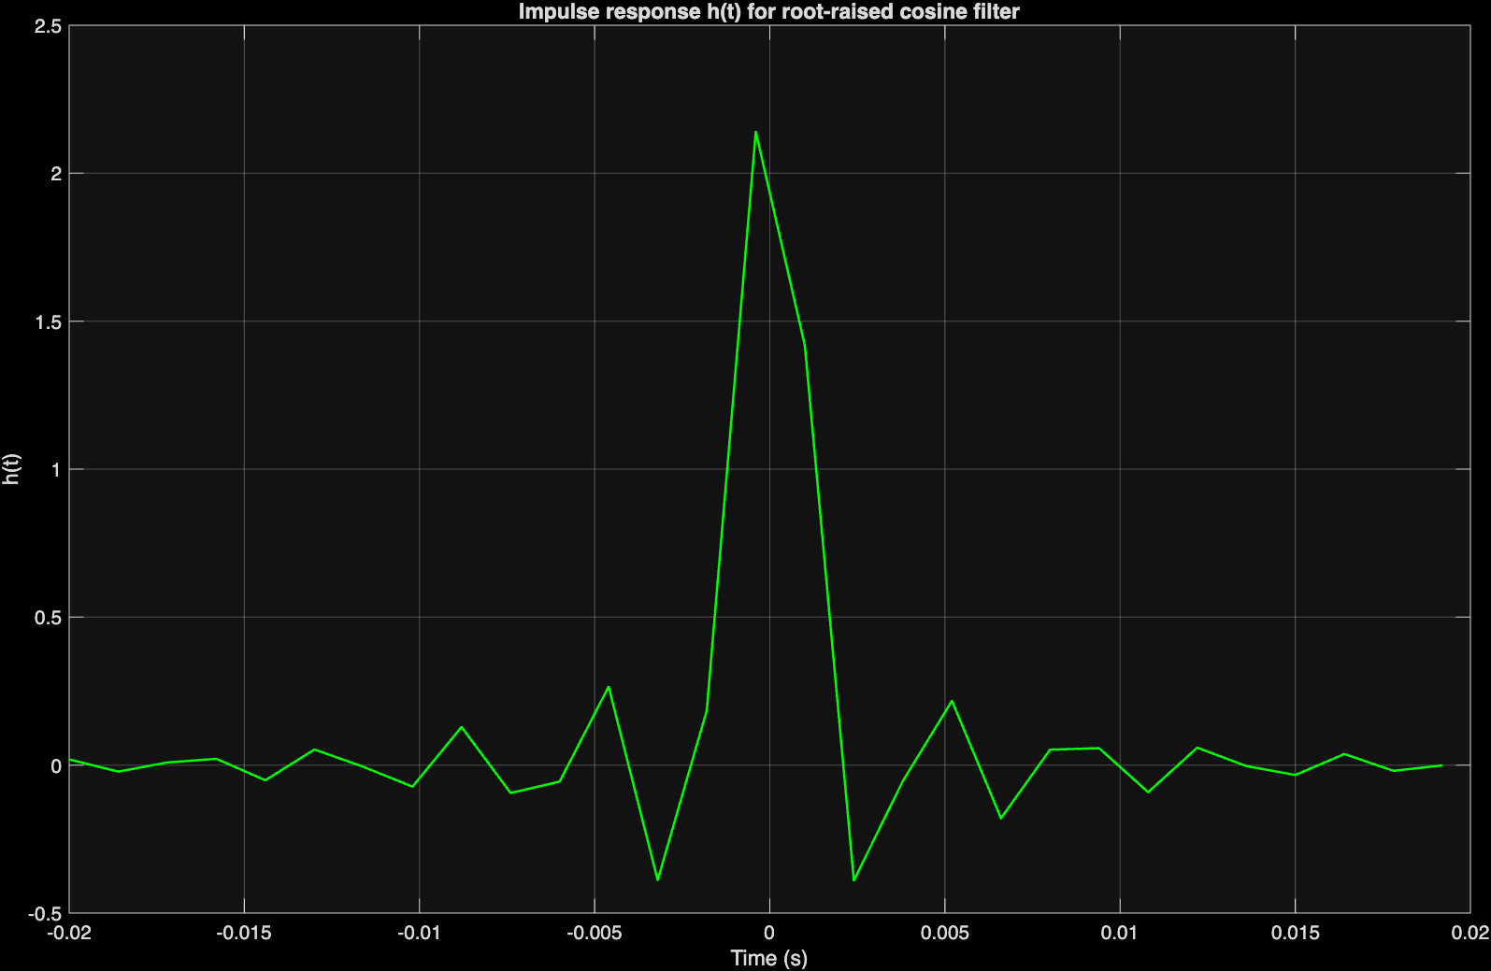 | 2) Son spectre d’amplitude

Insérer le code ici
%% Experiment 3 : Root-raised cosine (RRC) filter (subject 1)

clc;
clear;
close all;

%% Parameters

T = 2e-3; % Symbol period (2 ms)
al = 0.1; % Roll-off factor alpha (subject 1)
Te = 1.4e-3; % Sampling period (s) (near 1.6ms)
Fs = 1 / Te; % Sampling frequency (Hz)

t = -10*T : Te : 10*T; % Time vector from -10T to +10T

%% Impulse response h(t) using the given formula

num = sin(pi*t/T * (1 - al)) + (4*al*t/T) .* cos(pi*t/T * (1 + al));
den = (pi*t/T) .* (1 - (4*al*t/T).^2);

h = (al / sqrt(T)) * (num ./ den);

% Handle singularity at t = 0 using theoretical limit
h(t == 0) = (1/sqrt(T)) * (1 - al + 4*al/pi);

%% 1) Time-domain visualization of h(t)

figure('Name','Impulse response h(t)');
plot(t, h, 'g', 'LineWidth', 1.2);
grid on;
xlabel('Time (s)');
ylabel('h(t)');
title('Impulse response h(t) for root-raised cosine filter');

%% 2) Amplitude spectrum of h(t)

NFFT = 2^12; % FFT length
H_freq = abs(fftshift(fft(h, NFFT))); % Magnitude spectrum (centered)
f = linspace(-Fs/2, Fs/2, NFFT); % Frequency axis (Hz)

figure('Name','Amplitude spectrum of h(t)');
plot(f, H_freq / max(H_freq), 'g', 'LineWidth', 1.2);
grid on;
xlabel('Frequency (Hz)');
ylabel('Normalized magnitude');
title('Normalized amplitude spectrum of h(t)');

%% Theoretical maximum frequency of the RRC filter

f_max_theoretical = (1 + al) / (2 * T); % Hz
fprintf('Theoretical maximum frequency : %.2f Hz (%.3f kHz)\n', ...
f_max_theoretical, f_max_theoretical/1000);

Expérience 4
- Un tel échantillonnage n’est pas règlementaire. Expliquer pourquoi (1 point)

Le signal contient des composantes à 124000 rad/s, soit des fréquences bien supérieures à Fe/2 = 500 Hz. Les conditions du théorème de Nyquist (Fe ≥ 2*fmax) ne sont donc pas respectées, ce qui provoque un repliement des composantes hautes fréquences dans la bande de base

Insérer les figures ici
2) | 3)  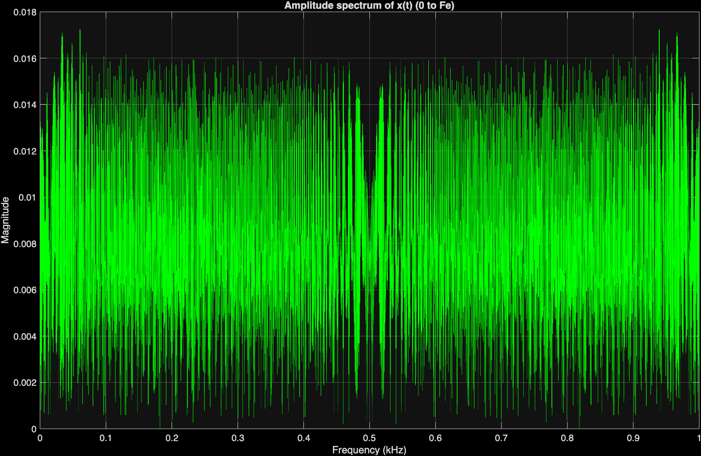
4)
Insérer la figure ici
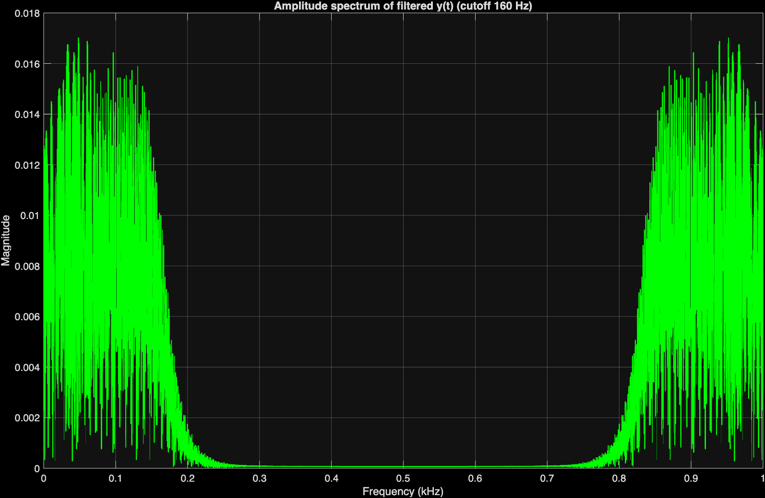
Insérer le code ici
%% Experiment 4 : Sampling and filtering (subject 1)

clc;
clear;
close all;

%% 1) Sampling parameters

Fe = 1000; % Sampling frequency (Hz) for subject 1
Te = 1 / Fe; % Sampling period (s)
t = (0:6400) * Te; % Observation window (0 to 6400 samples -> 6.4 s)

%% 2) Generate x(t)
% x(t) = sin(2000 t^2) + sin(2000 t)^2/100 + sin(2000 t)/100
% + cos(124000 t + pi/2) + sin(124000 t)

x = sin(2000*t.^2) ...
+ (sin(2000*t).^2)/100 ...
+ sin(2000*t)/100 ...
+ cos(124000*t + pi/2) ...
+ sin(124000*t);

%% 3) Amplitude spectrum of x(t) (0..Fe, axis in kHz)

N = length(x);
Xfft = abs(fft(x)) / N; % linear magnitude spectrum
f_Hz = (0:N-1) * (Fe/N); % frequency axis from 0 to Fe (Hz)
f_kHz = f_Hz / 1000; % in kHz

figure('Name','Amplitude spectrum of x(t)');
plot(f_kHz, Xfft, 'g');
title('Amplitude spectrum of x(t) (0 to Fe)');
xlabel('Frequency (kHz)');
ylabel('Magnitude');
xlim([0 Fe/1000]); % 0 .. Fe in kHz
grid on;

%% 4) 8th-order Butterworth low-pass filter (cutoff adapted)

% In the original statement Fe = 5 kHz with Fc = 800 Hz.
% Here Fe is 5 times smaller, so we scale the cutoff: Fc = 800/5 = 160 Hz.
Fc = 160; % cutoff frequency (Hz)
order = 8; % filter order
Wn = Fc / (Fe/2); % normalized cutoff (0..1)

[b, a] = butter(order, Wn, 'low'); % Butterworth low-pass filter

%% 5) Filter the signal to obtain y(t)

y = filter(b, a, x);

%% 6) Amplitude spectrum of filtered signal y(t)

Yfft = abs(fft(y)) / N;
figure('Name','Amplitude spectrum of filtered signal y(t)');
plot(f_kHz, Yfft, 'g', 'LineWidth', 1.2);
title(['Amplitude spectrum of filtered y(t) (cutoff ', num2str(Fc), ' Hz)']);
xlabel('Frequency (kHz)');
ylabel('Magnitude');
xlim([0 Fe/1000]);
grid on;

